Algebra 1
Standard | 3.0 Items
A.2(A) determine the domain and range of a linear function in mathematical problems; determine reasonable domain and range values for real-world situations, both continuous and discrete; and represent domain and range using inequalities | A.2A/3.0  - What is the domain of $y=-2x+3$?  - What is the range of the graph shown below?  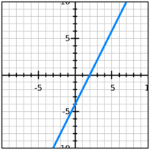  - Anthony makes $14 an hour working at the skating rink. He can work for a maximum of 25 hours per week. Let x represent the hours worked and y represent Anthony’s earnings per week. What is a reasonable range for this situation? Write your response verbally and algebraically.  - The total cost in dollars for car repairs can be found using the function $=175+21h$ , where $h$ is the number of hours worked. If the mechanic works for at least 3 hours but not more than 5 hours, what is the domain for the function for this situation?  - Jessica is going to the Houston Rodeo. Admission to the fair is $8 and each ride cost $4. Jessica has $40 to spend. Let x represent the number of rides and y represent the total spent. What is a reasonable domain?  - Ashley bought bracelets online. There was a $5.35 shipping fee and each necklace cost $8.95. The function $y=8.95x+5.35$ represents the cost of the order when $x$ represents the number of necklaces she bought. She wants to buy at least 3 but not more than 7. Give a reasonable range for this situation.
 | 2.0 Items
A.2(A)/2.0
Anthony makes $14 an hour working at the skating rink. He can work for a maximum of 25 hours per week. Let x represent the hours worked and y represent Anthony’s earnings per week.
- Is the following situation discrete or continuous?

- How would you represent the domain and range of this situation?
- With inequalities
- As a set

A.2(A)/2.0
Define domain

A.2(A)/2.0
Define range

A.2(A)/2.0 - Release Algebra I STAAR 2014 Q10
The mapping below represents all of the points on the graph of function $f$.

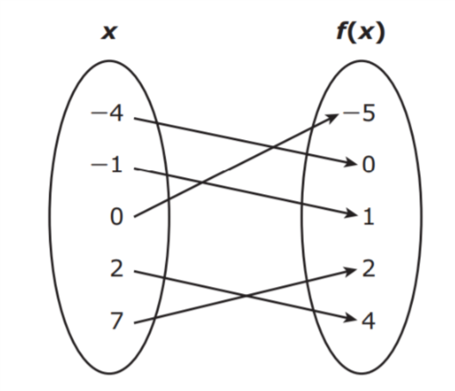

- What is the domain of $f$?

- What is the range of $f$?

A.2(A)/2.0 - Release Algebra I STAAR 2014 Q17 (partial)
The graph shows the relationship between the number of cookies a presenter at a convention had left to give away and the number of presentations she had made.

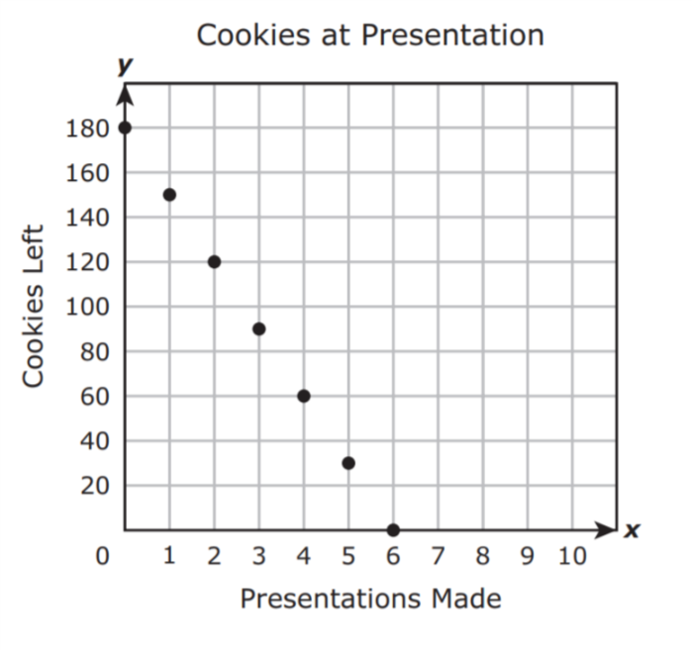

- What is the domain of $f$?

- What is the range of $f$?

A.2(A)/2.0 - Release Algebra I STAAR 2013 Q13 (partial)

Which of the following graphs has a range of all real numbers greater than 7?
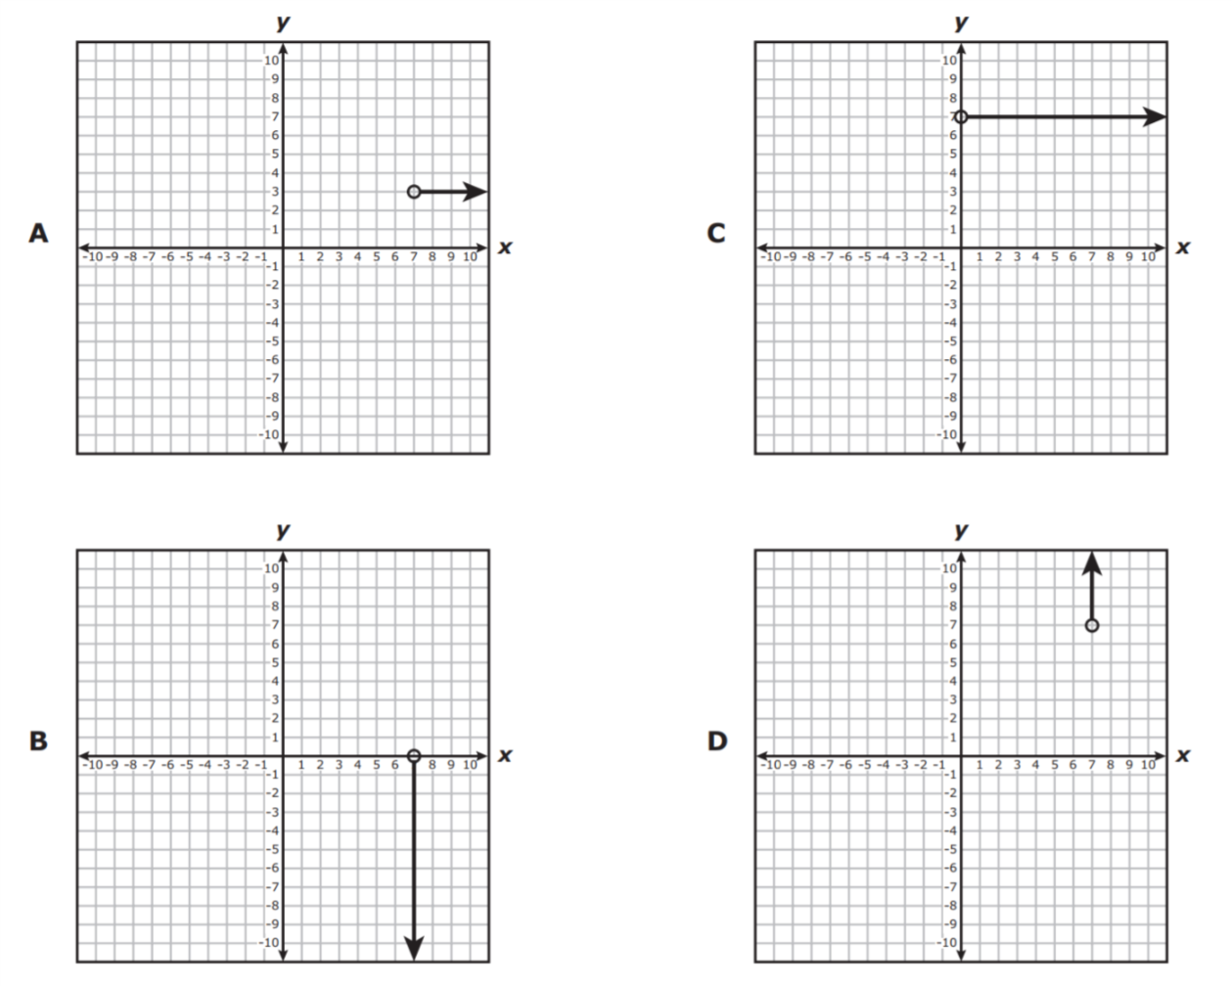

A.2(A)/2.0

What is the domain for the list of ordered pairs shown below?

(-3, -20) (0, -8) (3, 4) (7, 20)

MAKE MULTIPLE CHOICE

Standard | 3.0 Items
A.3(B) calculate the rate of change of a linear function represented tabularly, graphically, or algebraically in context of mathematical and real-world problems  A.3(A) determine the slope of a line given a table of values, a graph, two points on the line, and an equation written in various forms, including y = mx + b, Ax + By = C, and y – y1 = m(x – x1) | A.3(B)/3.0  Each of the following is a representation of a linear function. Find the rate of change of y with respect to x for each representation.  Release Algebra I STAAR 2016 Q19 (partial)  - 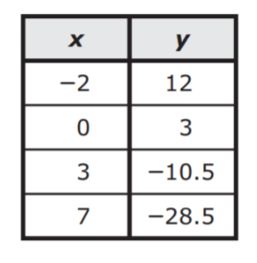  - $y=1/2x-5$  Release Algebra I STAAR 2016 Q7 (graph)  - 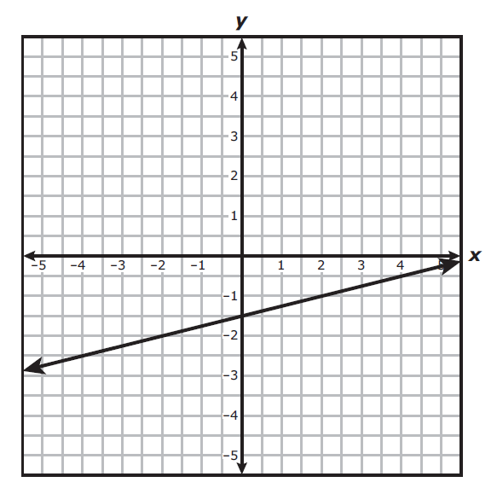  - A carnival charges $12 for admission into the park and $2.50 to ride each rollercoaster.  - On Friday, Kyndell bought 3 necklaces online for $38.25 plus a $12 shipping charge. On Saturday she bought 5 more necklaces at the same price for $55.75 with the same shipping charge. What is the cost of each necklace? (MAKE WORDING BETTER)  Release Algebra I STAAR 2013 Q42 (partial)  - The table below shows the total number of dishes washed as a function of the number of times the dishwasher is used. What is the rate of change of the number of dishes washed with respect to the number of times the dishwasher is used. 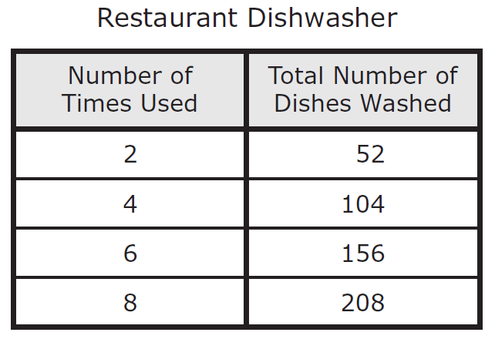  Release Algebra I STAAR 2016 Q1  - A savings account balance can be modeled by the graph of the linear function shown on the grid. What is the rate of change of the balance with respect to the number of deposits?  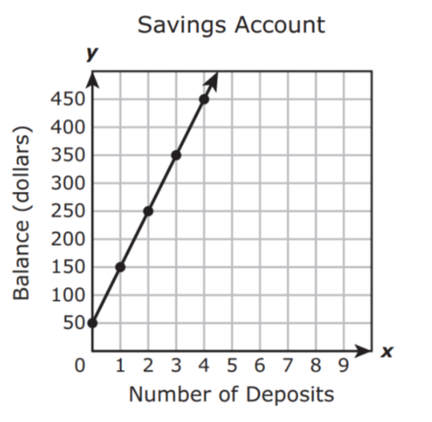  What is the rate of change of the balance with respect to the number of deposits?  A $100 per deposit  B $50 per deposit  C $0.50 per deposit  D $2 per deposit
 | 2.0 Items
- A.3A questions with different equation forms
- Determine if slope plugged into formula correctly (8th grade question)

Standard | 3.0 Items
A.3(C) graph linear functions on the coordinate plane and identify key features, including x-intercept, y-intercept, zeros, and slope, in mathematical and real-world problems | A.3(C)/3.0  - Graph the linear function $y=3/5x-3$on the grid below.  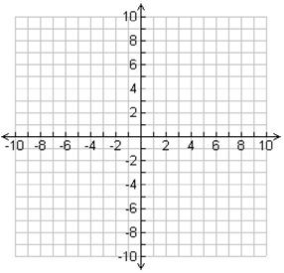  - What is the x-intercept of the linear function?  - What is the y-intercept of the linear function?  - What are the zeros of the linear function?  - What is the slope of the linear function?  - Kenny stopped at a gas station to fill up his tank for his 20 hour road trip ahead. The truck’s tank holds 200 gallons when it is full. As Kenny drives, the truck loses 10 gallons each hour during for the entire trip.  - Graph the linear function that represents this situation.  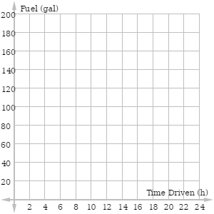  - Determine the slope of the graph.  - Identify the x-intercept and explain the meaning of the value of the x-intercept.  - Identify the y-intercept and explain the meaning of the value of the y-intercept.  - Identify any zeros and explain the meaning of the value of the zeros.
 | 2.0 Items
- Give linear functions in other representations for them to graph and then identify the key feature
- Let it be graphed already and ask about the features
- Define each of the key features

Standard | 3.0 Items
A.5(A) solve linear equations in one variable, including those for which the application of the distributive property is necessary and for which variables are included on both sides  Embedded:  A.5(B) solve linear inequalities in one variable, including those for which the application of the distributive property is necessary and for which variables are included on both sides | A.5(A)/3.0  Release Algebra I STAAR 2016 Q8, 52, 33  Solve the following linear equation or inequality..  - What is the solution to 0.3(12x - 16) = 0.4(12 - 3x)?  - What value of x makes the equation 5x - (-7- 4x) = -2(3x - 4) true?  - Which inequality describes all the solutions to 5(3 - x) < -2x + 6?  A x < 9  B x > 3  C x < 3  D x > 7
 | 2.0 Items
Solve the following linear equation or inequality.

- 4(x+3) = 20
- ½(8x - 14) = 13
- -3(2x-4) = 20
- 6x+3 = 8x+13
- 2(x - 5) > 30

Standard | 3.0 Items
A.2(C) write linear equations in two variables given a table of values, a graph, and a verbal description
 | 2.0 Items
Standard | 3.0 Items
 | 2.0 Items

